import matplotlib.pyplot as cricket
Overs=list(range(5,51,5))
Indian_Score=[30,55,90,129,165,200,239,270,310,350]
Srilankan_Score=[25,70,90,120,140,170,195,220,255,279]
cricket.plot(Overs,Indian_Score)
cricket.plot(Overs,Srilankan_Score)
cricket.show()
cricket.title("INDIA Vs SRILANKA")
cricket.xlabel("Overs")
cricket.ylabel("Score")
cricket.legend()
cricket.plot(Overs,Indian_Score,color="green",label="INDIA")
cricket.plot(Overs,Srilankan_Score,color="red",label="SRILANKA")
cricket.legend(loc="center right")

OUTPUT

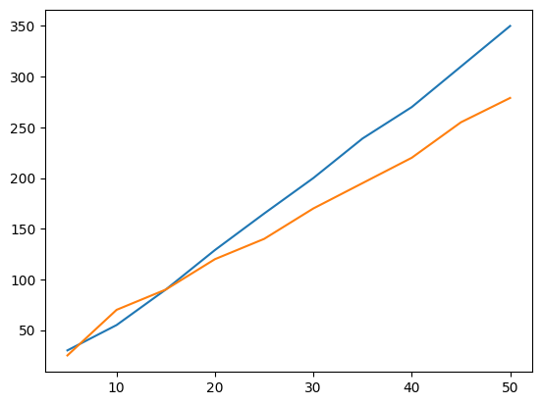
/tmp/ipykernel_7773/506286342.py:11: UserWarning: No artists with labels found to put in legend. Note that artists whose label start with an underscore are ignored when legend() is called with no argument.
cricket.legend()

<matplotlib.legend.Legend at 0x7ff44d993d90>
